**1.get_hot_posts**

**2.get_user_info**

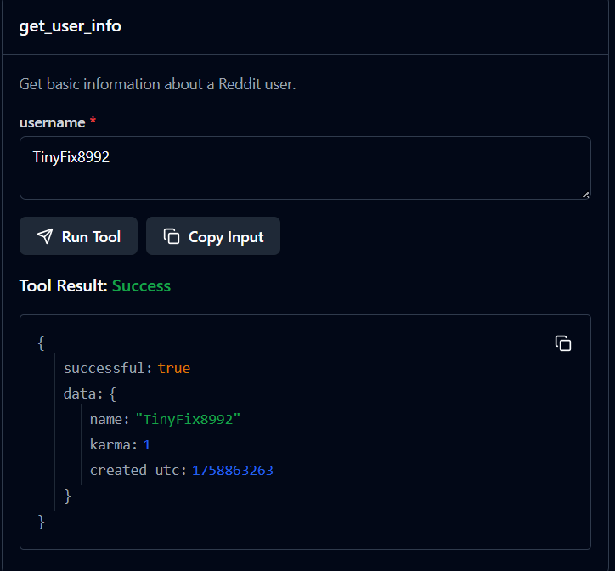

**3.create_reddit_post**

**4. post_reddit_comment**

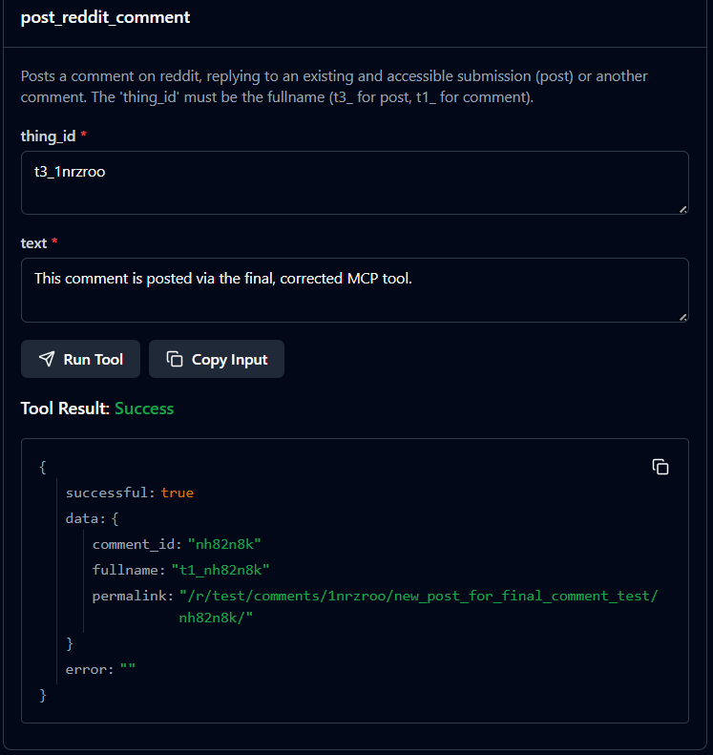

**5. delete_reddit_comment**

**6. edit_reddit_content**

**7. get_link_flair**

**8. retrieve_post_comments**

**9. post_reddit_comment**

**10. retrieve_reddit_posts**

**11. retrieve_specific_content**

**13. get_subreddit_details**

**14. get_new_submissions**

**15. get_top_posts**

**16. get_submission_details**

**17. get_submission_details**

**18. search_subreddits**

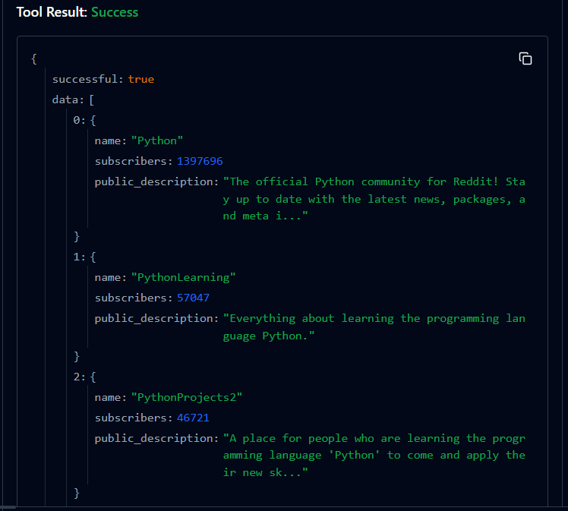

**19.get_redditor_trophies**

**20.get_subreddit_rules**

**21.get_subreddit_listing**

**22. get_subreddit_sidebar**

**23. get_subreddits_by_topic**

**24. get_moderators**

**25. get_gilded_content**

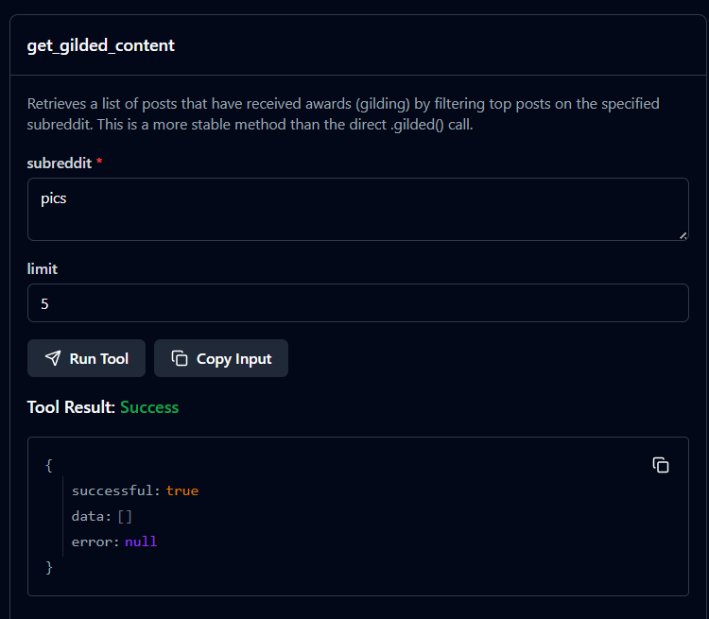

**26.list_multireddits**

**27.get_blocked_users**

**28. list_approved_submitters**

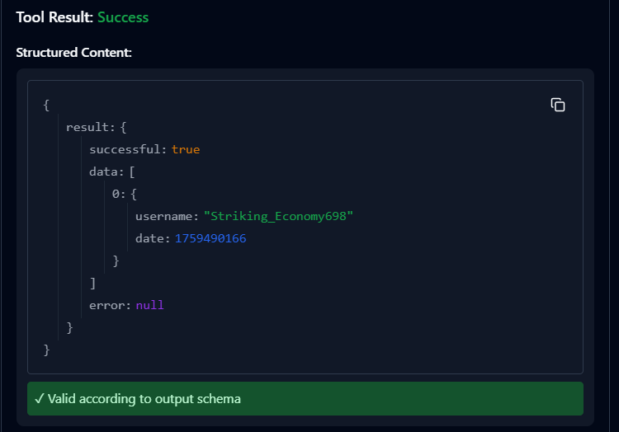

**29. get_controversial_posts**

**30. list_user_friends**

**31. get_trending_posts**

**31. get_reddit_age**

**32. get_user_follower_count**

**33. get_best_feed**

**34. crosspost_submission**

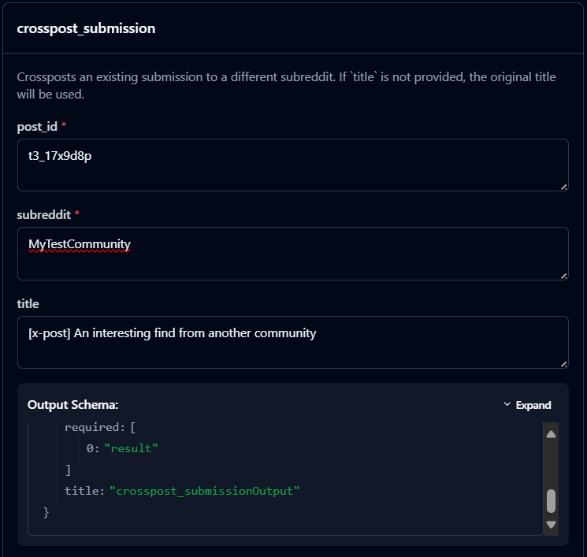

**35. get_community_age_rating**

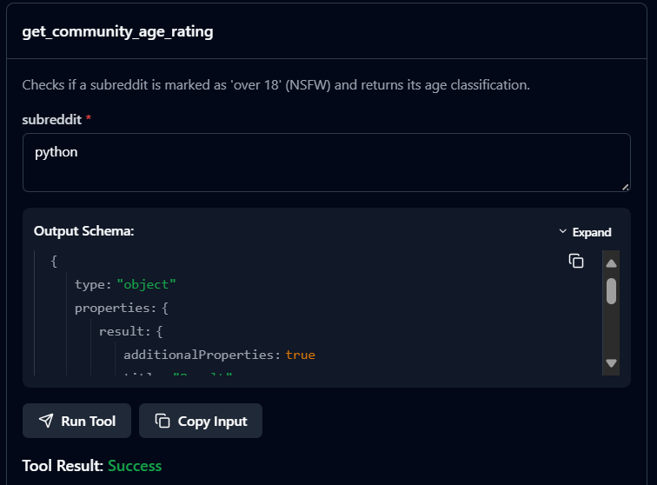

**36. get_rising_posts**

